**Stresstest**

The goal is to create a bar plot which shows the cumulative portfolio returns for specific periods f.e. the financial crisis of 2008.

As input 3 files will be used:

1. «New Weights.xlsx» shows the percentage weights the client is invested
2. «Data4StressTest.xlsx» has the time series returns of the respective underlyings.
3. « Benchmarks.xlsx » which will be used later fort he second bar (see below)

**The second bar (green) in the plot**

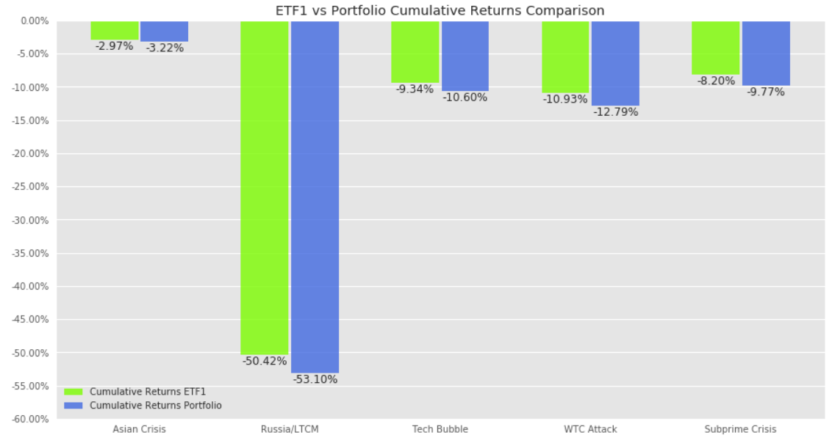

The green bars are the calculated based on the following logic :

In the weights DataFrame (‘New Weights.xlsx’) there is a column called «Risk Profile»

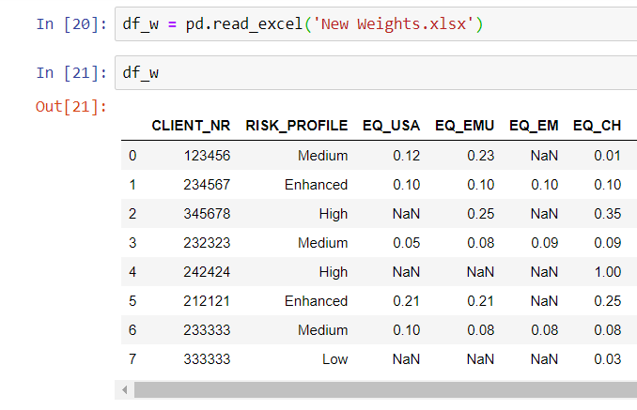

Depending on what is written in the «Risk Profile» Column a different Benchmark must be used.

Benchmarks must be taken from the file «Benchmarks.xlsx»

If the Risk Profile in «New Weights.xlsx» says Medium then the Benchmark Medium from the «Benchmarks.xlsx» file should be used.

All other steps to calculte the cumulative return for the bar are the same.